**DAY CARE**

REPORT

BY

**PABITRA KUMAR PANDA**

BACKGROUND

1. Introduction

Day care refers to the care provided for infants and toddlers, preschoolers, and school-aged children, either in their own homes, in the home of a relative or other caregiver, or in a center-based facility.

The last half of the twentieth century saw a dramatic rise in the numbers of women with young children who worked outside of the home. In 2000, 55 percent of mothers with infants were in the labor force. In 2001, 64 percent of mothers with children under the age of six, and 78 percent of mothers with children ages six to seventeen were in the labor force. These developments led to an increased demand for childcare providers by parents while they are at work.

In 2001, 61 percent of all children participated in some sort of nonparental care. As children grow older, the likelihood they will receive care from someone other than a parent increases.

1. Objective

To create a website that is easy to learn and easy to use for a new user or a first time user. The website focus on the users and their needs in each phage of the design process. The site is created by doing to many researches and design techniques, to create highly usable and accessible products for the user.

1. It is useful for whom?

It is useful for both children and parents by:

* 1. Socialization and interaction
  2. Connection and communication
  3. Consistency and Routine
  4. Autonomy and Independence

1. Feature of My website
2. Easy and simple design which is easy to use
3. Having a feature of camera where parents can watch on to their child.
4. Feature of scheduling pick up and drop.
5. Having a feature of doctor where we can call instantly in one click.
6. Give a health care report of your child.
7. In this parents can plan their children diet plans.

FLOW DIAGRAM

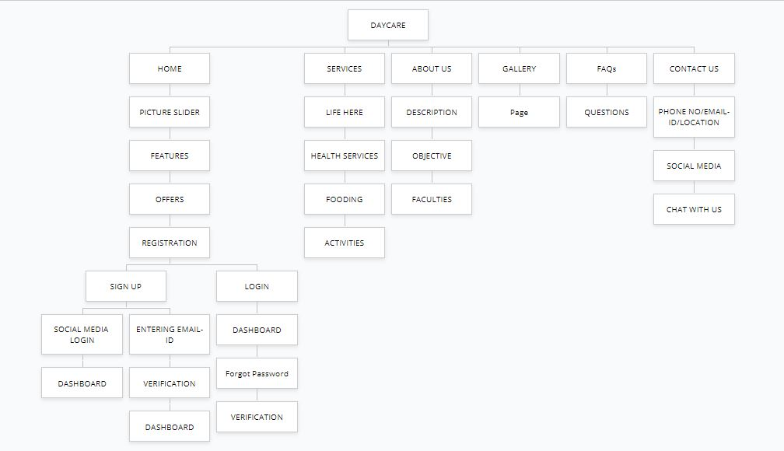

WIREFRAME MODEL

COM.NAME

HOME SERVICES ABOUT US GALLERY FAQs CONTACT US LOGIN/SIGN UP

SOCIAL MEDIA HANDLERS

PHONE NO

EMAIL-ID

ADDRESS

HIGH FIEDALITY MODEL

Adobe-XD link- https://xd.adobe.com/view/1dd7889d-80d5-4697-8a55-e482f7c4530c-4884/

